

A Student’s Guide to
REVISION


How the brain works

Revising is all about MEMORY. The memory is like a muscle. If you don’t exercise it, it will grow weaker, but if you do exercise it, it will get stronger and stronger.

TAKE LOTS OF BREAKS
Most people can only concentrate, understand and remember for between 20 and 45 minutes at a time.

DO NOT REVISE FOR LONGER WITHOUT A BREAK.

If you do, most of what you do, you will not remember.

Once you have finished learning something, your brain actually increases its power and carries on remembering. It will be sorting out what it has been learning, creating a more complete picture of everything it has just learnt. Only then does the rapid decline in memory begin and as much as 80% of what you learn in a day can be forgotten almost immediately.

BUT WHAT CAN I DO TO STOP THIS?
To maximize your learning, you need to catch the top of the wave of your memory. To do this, you need to look back at what you have been revising at the correct time, when the memory is stamped in far more strongly, and stays at the crest of the wave for a much longer time. Look at the diagram below:
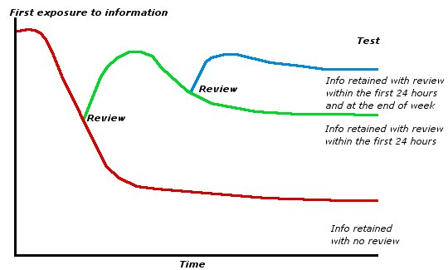

YOU NEED TO REVIEW WHAT YOU HAVE LEARNT:
- After 10 minutes
- At the end of the day
- At the end of the week
- At the end of the month

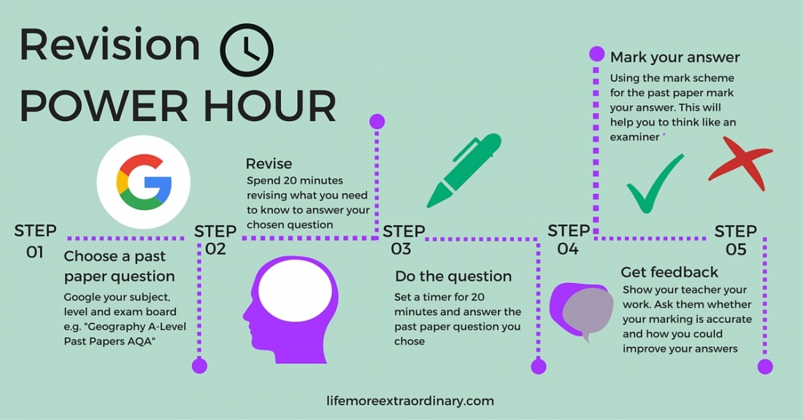
What type of learner are you?

Tick the statements which best describe you, your actions and the things that you say.

- “I see what you mean”
- “That sounds right”
- “That feels right”
- “I get the picture”
- “I hear what you are saying”
- “I found it easy to handle”
- “That looks about right”
- “That rings a bell”
- “That touched a nerve”
- When relaxing, I like to watch a film or video.
- When relaxing, I like to listen to music
- When relaxing, I like to go to the gym
- I like to read a book to relax
- When relaxing, I like to listen to the radio
- When relaxing, I play sport
- I prefer to talk to people face to face
- I prefer to talk to people on the telephone
- I prefer to talk to people whilst I’m doing something else
- I get impatient when I listen to others
- I like listening to others
- I wave my hands about a lot when I’m talking
- I forget people’s names, but I remember their faces
- I don’t forget people’s names
- I shake hands when I meet people
- If I’m lost or need directions, I prefer a map

- If I’m lost or need directions, I prefer to be told
- If I’m lost or need directions, I prefer to be shown the way
- When I’m bored, I doodle
- When I’m bored I tend to chat
- When I’m bored, I fidget
- When I’m angry, I seethe and say nothing
- When I’m angry, I have an outburst and sometimes shout
- When I’m angry, I clench my teeth or storm off
- When I want to reward someone, I write them a note or send them a card
- When I want to reward someone, I tell them
- When I want to reward someone, I pat them on the back or hug them
- I’m well organised
- I don’t like reading books or instruction manuals
- I can’t sit still for very long

What type of learner are you?

Now check your learning style:

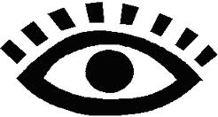

- Visual learner
I ticked the following questions:

1, 4, 7, 10, 13, 16, 19, 22, 25, 28, 31, 34, 37

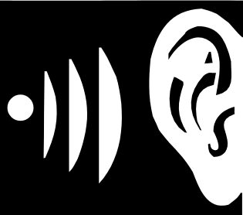
- Auditory learner

I ticked the following questions:

2, 5, 8, 11, 14, 17, 20, 23, 26, 29, 32, 35, 38

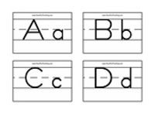

- Kinaesthetic learner

I ticked the following questions:

3, 6, 9, 12, 15, 18, 21, 24, 27, 30, 33, 36, 39

Good techniques for you to use

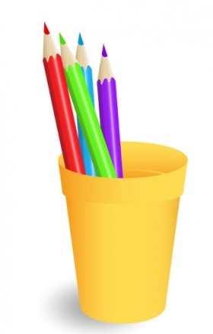
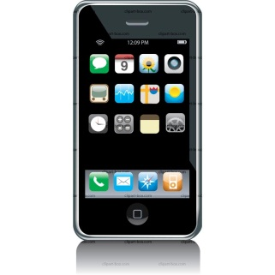
Auditory Learners

Hearing a presentation
Reading aloud to yourself
Making a take with key points to listen to
Verbally summarizing
Explaining your subject to someone else
Talking to yourself
Make a podcast
Using Mnemonics
Use computer software
KINAESTHETIC LEARNERS

Using highlighters to select key words, main ideas before making notes. Use a black out pen to block out unnecessary words.

Make flash cards

Make sort cards and put into order

Make models

Record information as you hear it – i.e. on a mind map

VISUAL LEARNERS

Writing down key facts

Using mind maps

Creating pictures and diagrams

Using timelines

Using pictures, diagrams and charts

Watching videos, films or TV programmes
Getting started

Before you start revising, it is worth making sure you have everything you need at your fingertips. This will stop you wasting valuable time trying to find things.
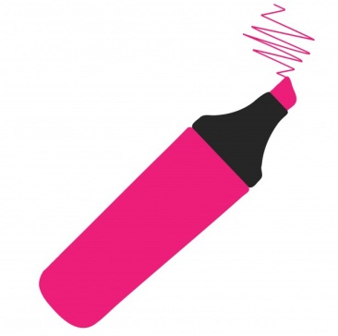
EQUIPMENT

- Highlighters
- Coloured pens
- Post-it notes for formula/key words
- Different coloured paper for different subjects (you will need lots of this)
- Cd player/computer for revision CD’s
- Smart phone for making podcasts
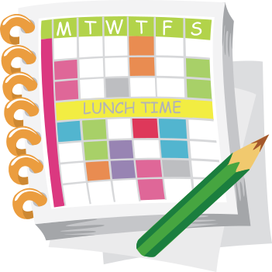

WHERE TO REVISE

- Not in front of the TV
- At a table, preferably in a quiet place
- It’s worth trying to sort the bedroom out. Get rid of the clutter, so you have work space.
- Keep all materials for each subject in one place to save time.
WHAT DO YOU NEED TO REVISE?
- Revision timetable
- An up to date set of class notes
- Any revision materials given out by departments
- Revision lists
- Lists of exactly what is in each exam
- Any study guides which have been bought (check with your teacher that it is the right one)
REVISION TIMETABLES

Topics need to be revised more than once based on what we know about the brain.

Think about the following:

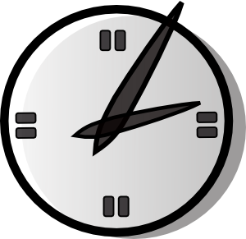
- Be realistic – remember sessions should only be for 30 – 40 minutes with 10 minute breaks
- Start NOW
- 2 sessions on a week night
- 3-4 sessions a day at the weekend
- During holidays revision should be far more intensive
- Build in treats – time with friends, evenings out etc. Social time is vital in the overall scheme, as long as there is a balance between work and play
- Try and get a variety of subjects across each day.
- Build in slots to review the learning of the day
- When you write next week’s timetable, remember to include review slots for the work covered last week
- Discuss with someone at home how you are going about your revision

Breaking it down:

If you’re thinking, “I’m doing Maths for 40 minutes and then half an hour of French”, think again! It means you haven’t broken the subject down into key areas to tackle your work in an organised manner; e.g. “I’m doing algebra and irregular verbs”. You should have a list of topics, and if not then you must ask your teachers for one.

You need to use those key headings to:

- Identify those topics you feel weak in – the danger is you push these to the back of your mind.
- Use each heading to break the topic down further. On the next page is one way of doing this.
TIP: At first, the big picture may look and feel totally overwhelming. You need to prioritise your workload. You need to be aware of the fact that revision takes time and for a few months, the social life has to give a bit. Why don’t you arrange with friends to have “time off” sessions together?


planning your revision

THINK LEVELS!

LEVEL ONE IS THE SUBJECT

LEVEL TWO IS THE TOPICS WITHIN THAT SUBJECT

LEVEL THREE IS THE INDIVIDUAL TOPIC DIVIDED INTO STUDY UNITS

SUBJECT

STUDY
UNITS

1

2

3

4

5
STUDY
UNITS

1

2

3

4

5
STUDY
UNITS

1

2

3

4

5
STUDY
UNITS

1

2

3

4

5
STUDY
UNITS

1

2

3

4

5
TOPIC
TOPIC
TOPIC
TOPIC
TOPIC
Timetable:

 | Mon | Tues | Wed | Thurs | Fri | Sat | Sun
8 am
9 am
10 am
11 am
12 noon
1 pm
2 pm
3 pm
4 pm
5 pm
6 pm
7 pm
8 pm
9 pm
10 pm

GENERAL REVISION STRATEGIES

The following 21 ideas can be used for turning class notes into revision notes across all subject areas.

- Deliberate aspects of a topic using a spider diagram
- Make a chart to fit the information
- Put key words onto Post-It Notes, stick then around the house to learn them
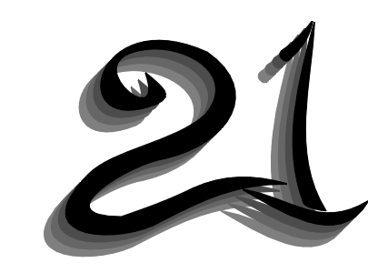
- Make up tests to try later
- Put notes onto revision cards
- Make your own flash cards – questions one side/answers on the back
- Create a Mind Map (see later section)
- Use different colours to represent different things
- Use Mnemonics for difficult spellings/sequences (e.g Richard of York Gave Battle In Vain – colours of rainbow)
- Make a flow chart
- Make a timeline
- Use pictures to represent key ideas
- List two sides of an argument
- Identify similarities/differences
- Plan an exam answer and write the first paragraph
- Create a dictionary for each subject
- Turn headings into questions
- Fill the bedroom walls with posters for key ideas
- Make up cartoons
- Label pictures
- Record key quotes/key terminology

